Hilado, Xyleen

Ungos, Carl Marco

**Machine Problem 4**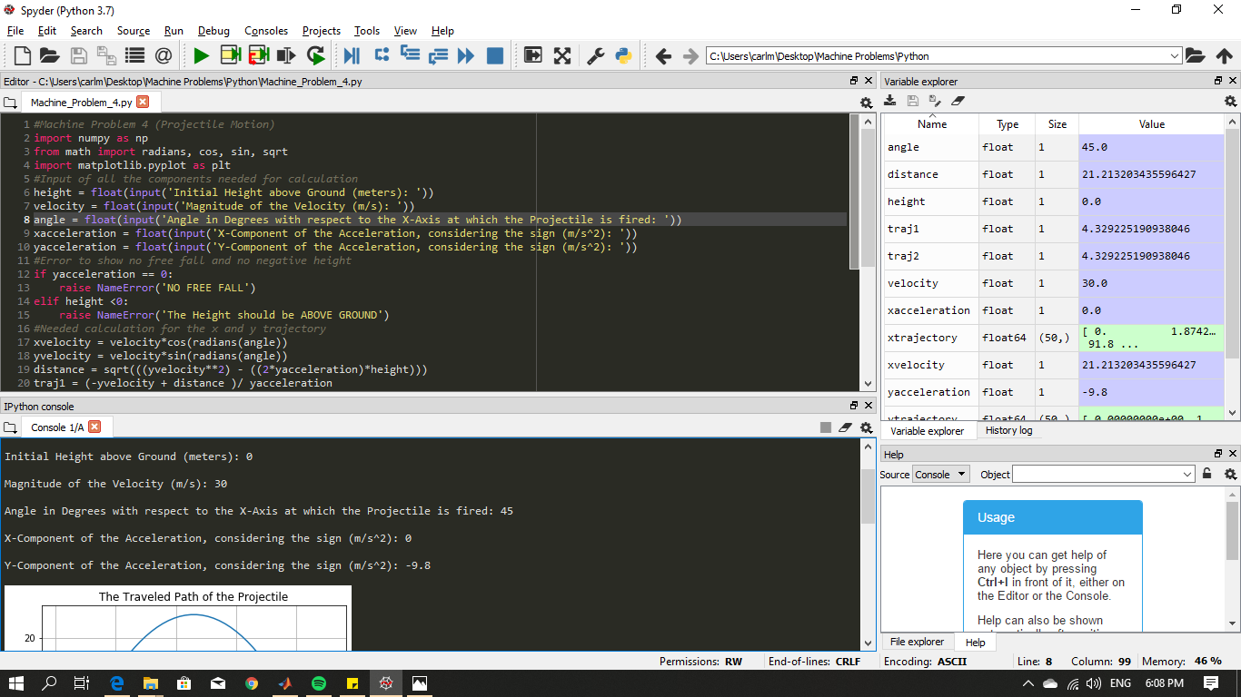

**Graph Without X- Component**

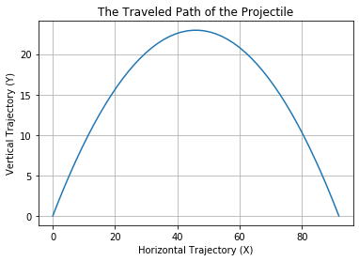

**Height Error**

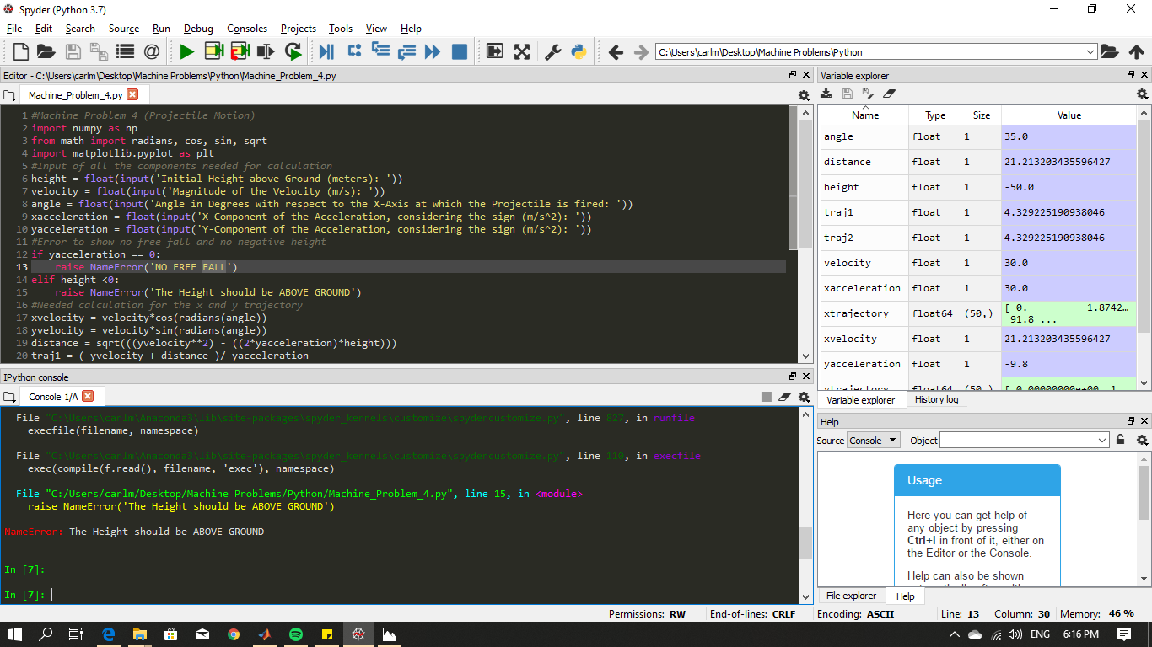

**Y-Component Error**

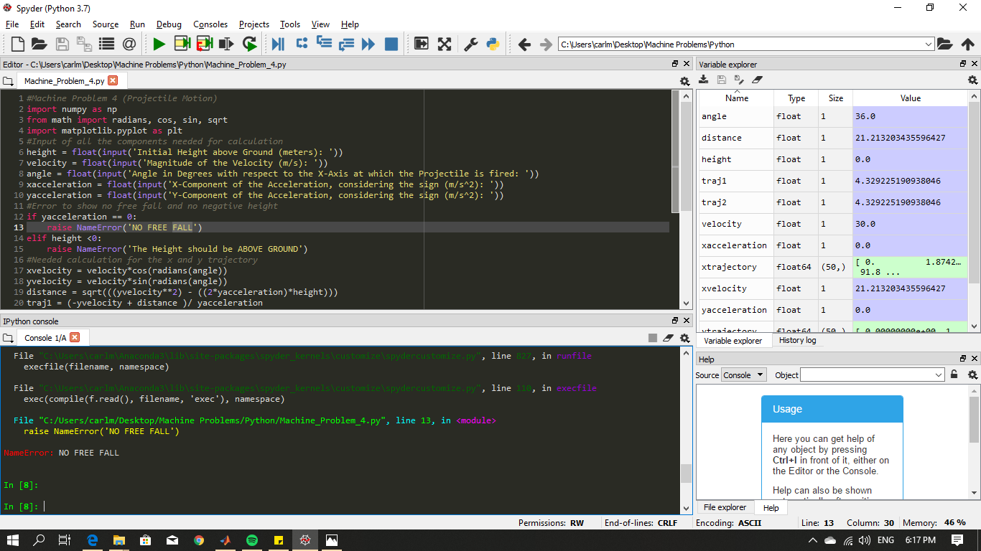

**With X- Component**

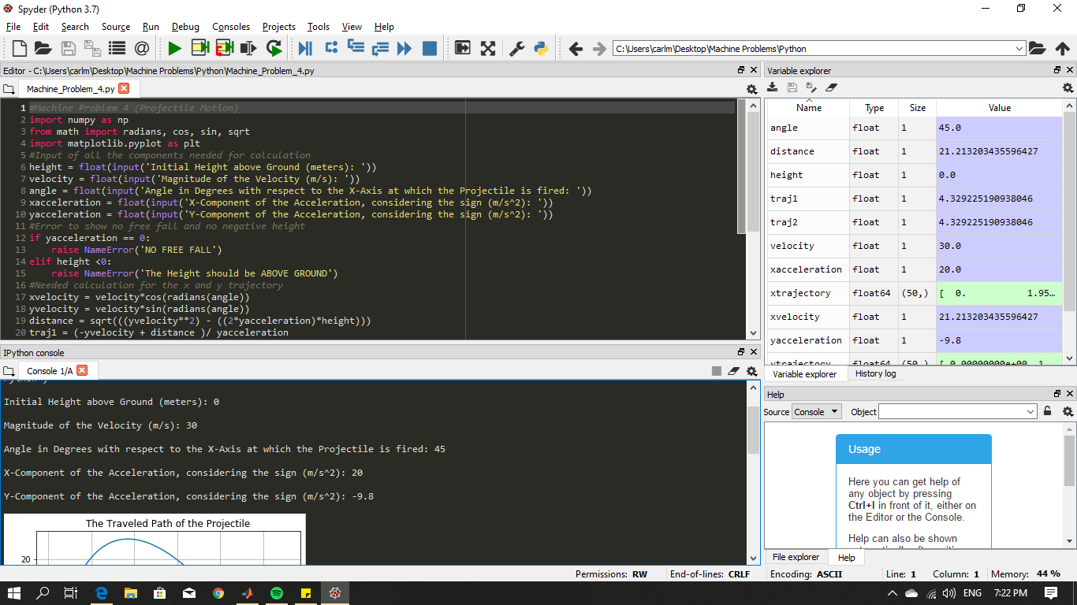

**Graph with X-Component**

